First we will create a new project.
First we will import all the playwright dependencies.
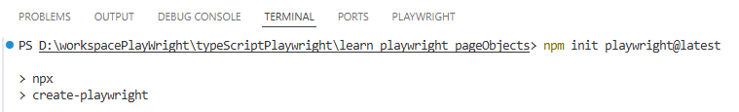
We will add allure report as well.
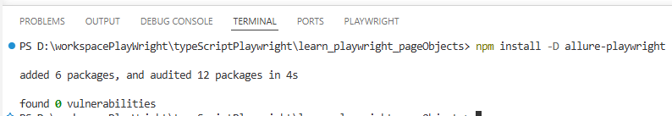
In the config file we will add allure playwright.
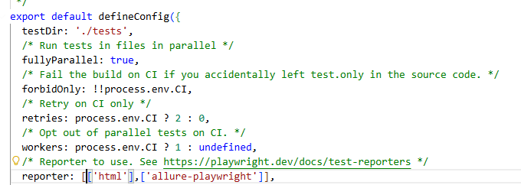
We will also make the following changes in the config file.
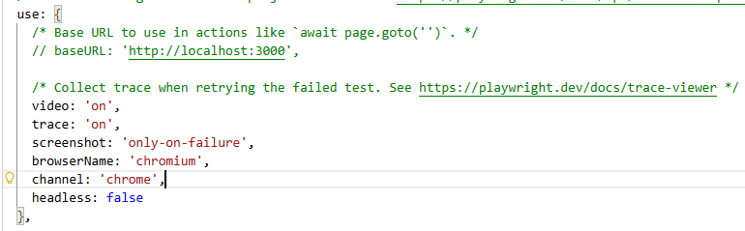
We can comment out webkit since we are on windows.
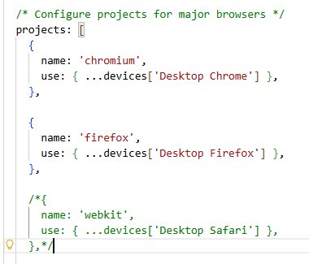
We will also add a timeout of 15000.
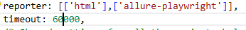
We will add 2 folders for pages and utils.
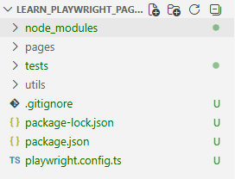
We will be automating https://www.carwale.com/
We will be adding the following in the base url
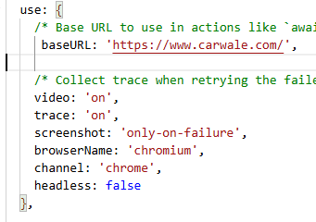
Here we will follow the page object model. This means for every page we will create once class file.
Instead of implementing the business logic in the test cases we will write the same in page object. This will also reduce script maintenance.
If there are multiple functionalities in a single page all of them will come under one class.
For this we will create a new file under pages called HomePage.ts
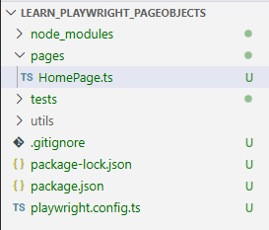
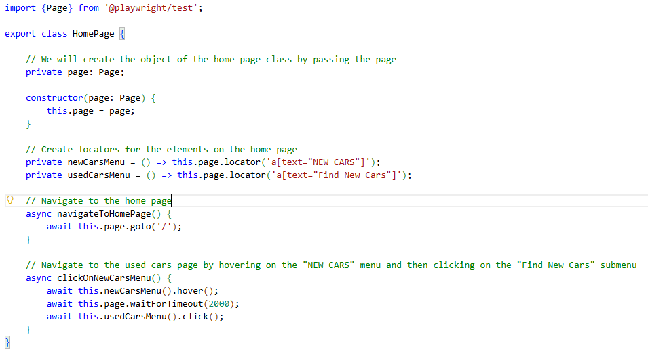
Next we will create a test file.
